

**FA18: CMPE-208 - Net Architecture and Protocol**

**LAB 1 – Address Resolution Protocol**

**by**

**Group – 01**

Jeevan Venkataramana(Jeevan.venkataramana@sjsu.edu)

Pavan Haravu Ramesh([pavan.haravuramesh@sjsu.edu](mailto:pavan.haravuramesh@sjsu.edu))

Roopashree Munegowda(roopashree.munegowda@sjsu.edu)

Sai Sree Vaishnavi Chittoori(saisreevaishnavi.chittoori@sjsu.edu)

**Submitted To: Shai Silberman**

**September 2018**

**Contribution of work**:

|  |  |
| --- | --- |
| Jeevan Venkataramana | Configuring GNS topology,ARP commands and analysis of ARP protocol. |
| Pavan Haravu Ramesh | Implementing Port-Channel and trunking, Configuration and its analysis. |
| Roopashree Munegowda | Configuring VLANs on cisco switches and Pruning VLANs on interfaces. |
| Sai Sree Vaishnavi Chittoori | Implementing Link Aggregation Control protocol and analysis of spanning tree protocol. |

**Lab Set up**:

1. **Tools used in lab environment:**

* GNS3 simulator.
* Mininet Virtual machine on oracle virtual box.
* Wireshark.

1. **Network topology:**

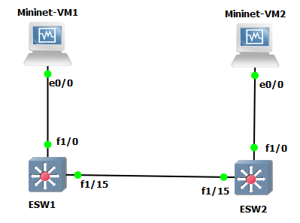

Two ethernet switches ESW1 and ESW2 are used.

Two mininet devices VM1 and VM2 are used.

1. **Connecting interfaces:**

Two ethernet switches are connected with a cable from fa1/15 (ESW1) to interface fa1/15(ESW2) and both the mininet VM1 and mininet VM2 are connected on interface fa1/0 to the ethernet switches respectively.

1. **Configuration setup**:

On ethernet switch 1(ESW1):



On ethernet switch 2(ESW2

On Mininet -VM1:

We have configured ip address 10.10.100.1 using the command below.

**“sudo ifconfig eth0 10.10.100.1 netmask 255.255.255.0 up”**



On Mininet -VM2:

We have configured ip address 10.10.100.2 using the command below.

**“sudo ifconfig eth0 10.10.100.2 netmask 255.255.255.0 up”**



**Objectives:**

To understand the working of the Address Resolution Protocol (ARP):

* Configure GNS Topology to test various layer two protocols.
* Experiment with ARP command.
* Learn how to configure VLANs on Cisco Switches.
* Learn how to prune VLANS on interfaces.
* Learn about LACP (Link Aggregation Control Protocol).
* Learn about and implement port-channel/trunking configuration.

**INTRODUCTION:**

**ADDRESS RESOLUTION PROTOCOL:**

Address Resolution protocol is used for the mapping of the logical address of layer 3 called ip

address to the layer 2 physical address mac address of the device. To send any data from one

host to another host, the sender host should have the mac address of the destination host as well.

This information will be maintained at the hosts. To get the mac-address of the destination host,

the layer 2 protocol called ARP will be used.

When an ARP request is sent through the network, the device holding the IP address replies with

its mac address to the device from which it got the request. An ARP request is a broadcast since

the device is unware to whom the IP address belongs to. Once the device receives the mac

address of the requested device through APR reply from the destination, it stores the information

in its mac address table called ARP cache. This ARP reply is a unicast message. This protocol is

used only for ipv4 network.

**ARP Cache:**

By default, an entry will be kept for a time period of about 20 minutes for reachable host and 3

mins for unreachable host, after which it gets expired. But the protocol works in such a way that

every time there is an exchange of packets between the device the timer gets reset. So, if some devices have communication between them then the ARP table is maintained and do not gets

expired. There are two basic types of ARP cache entries:

One is the static ARP entry: in which the user manually enters the mac address of the device.

One of the reasons to add static entry is to reduce network overhead between the devices which

are constantly in communication with each other, But this requires a lot of effort for the network

administrator to manage the devices with static entries.

Second is dynamic ARP entry: In dynamic mapping the network automatically updates its cache

entry which are in form of tables containing the mapping of hardware address and the IP address.

Arp cache maintains the most recent entry of the ARP mappings of the devices. For example, if

an ARP reply packet is received by a device by another device then it will update the mapping in

case of the entry is different. This can occur when the hardware of the device has been changed.

**ARP packet format**:

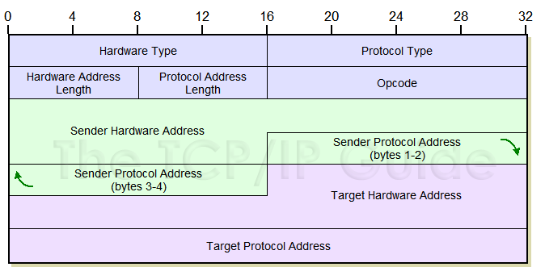

**Hardware Type**: This field specifies the network protocol type. For ethernet the value is 1.

**Hardware Address length**: This field specifies the ethernet or mac address of the

device. Its length is generally 6 bytes.

**Protocol Type**: This field is used for the protocol type for which the ARP request is used. For

IPv4, the value used is 0x0800.

**Protocol Address length**: The length of address in layer three protocol. The value for IPv4 is 4

bytes.

**Opcode**: The operation that is being performed. The value is 1 for request and 2 for reply.

Sender Hardware Address: Ethernet/Mac address of the sender.

**Sender Protocol Address**: IP address of the sender.

**Target protocol address**: IP address of the receiver.

**Target Hardware Address**: Ethernet/mac Address of the receiver. If the packet is arp request

packet the value is 00:00:00: 00:00:00.

**1.Observing ARP tables:**

a) Executing “show arp” on switches:

* ESW1:



* ESW2:



When one host tries to send (sender host) ping messages to another host (destination host), since there is no entry of the mac address of the destination host in its arp cache, then sender host will send the broadcast messages to all the PCs attached to the network by mentioning the IP address of the destination host for which it requires the mac-address.

b) Executing “arp -a” on mininets:

* Mininet-VM1:

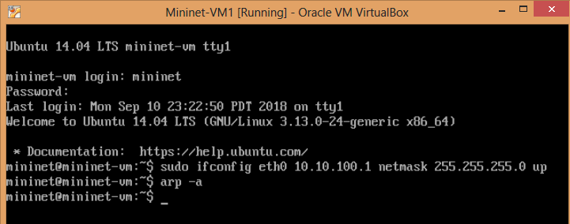

* Mininet-VM2:

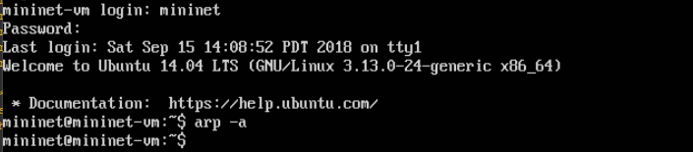

As we can see in the above screenshot arp output is blank which indicates that no communication is initiated between mininets.

**2. Executing “show mac-address” on switches:**

* ESW1:

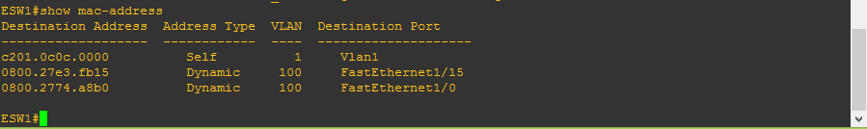

* ESW2:

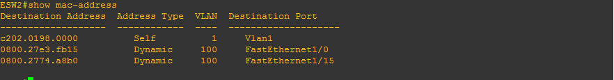

**3. Executing “ping” from mininet-VM1 to mininet-VM2**

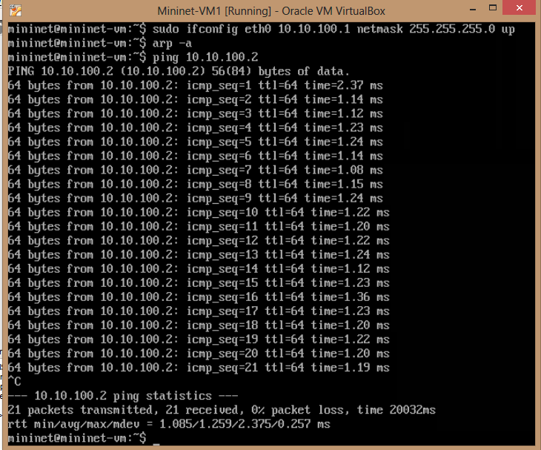

The ping works and hence indicates communication between mininet1 and mininet 2.

**4. Executing “ping” from mininet-VM2 to mininet-VM1**

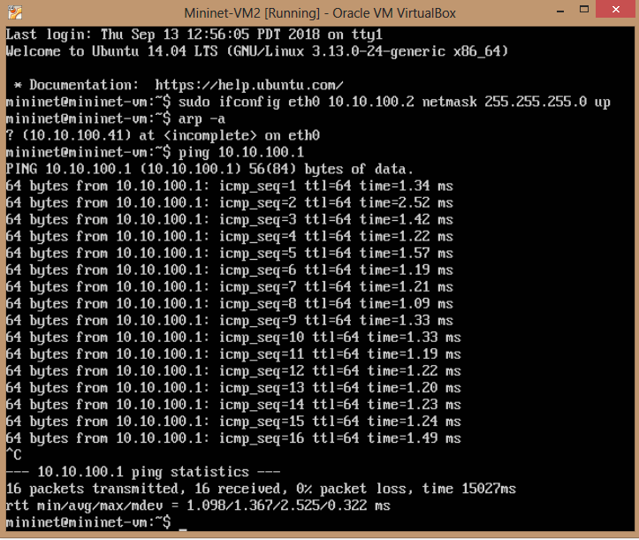

Same result is observed as mininet 1.

**5. Observation of ARP tables after ping execution:**

a) Executing “show arp” on switches:

* ESW1:

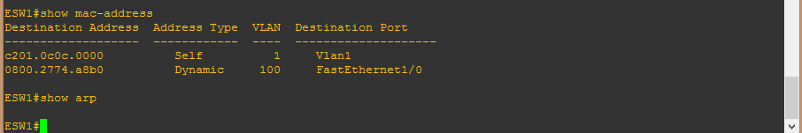

* ESW2:

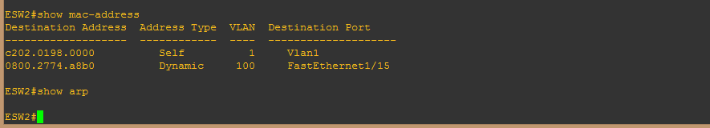

“show arp” execution on the switches gives us a blank output which indicates that ip addresses were not available. ARP was not able to map ip address into mac address.

b) Executing “arp -a” on mininets:

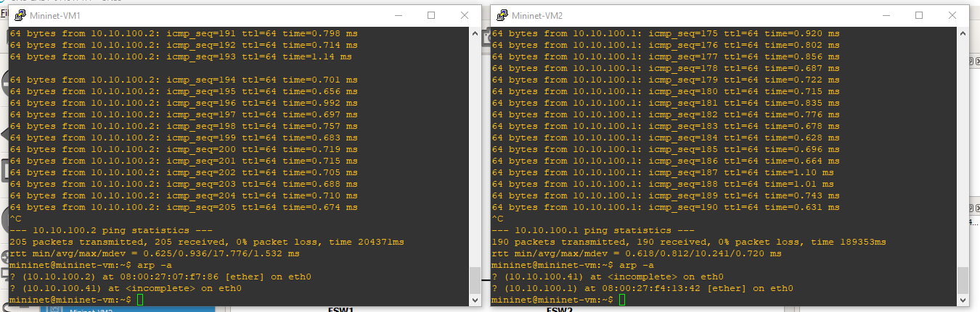

We executed “arp –a” again after the execution of ping command. Since there was a connection between mininet 1 and 2,the following output was observed.

Observation states that arp is used to determine hardware addresses corresponding to the IPV4 addresses which are in use on the locally reachable IPV4 subnet via Ethernet (eth0) connection.

**6. Executing “show spanning-tree vlan 100 br” on switches**:

* ESW1:

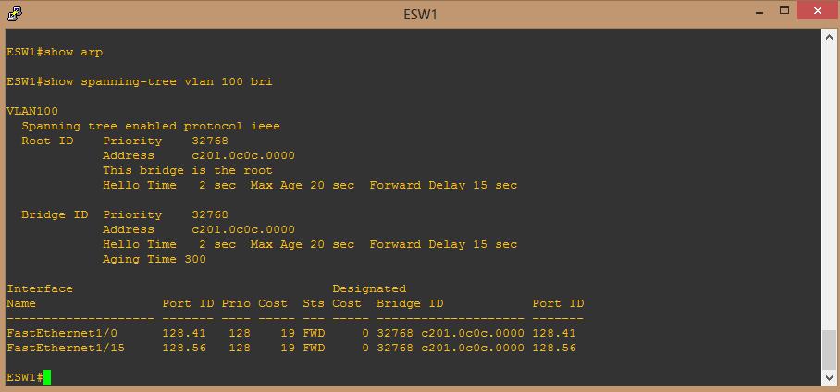

* ESW2:



The above output gives us a brief idea about the spanning tree. It tells us that spanning tree is enabled for VLAN 100. It shows us the interface associated cost and state.

**VLAN Pruning:**

VLAN pruning is used to communicate vlan information between ESW1 and ESW2 which stops any updated information traffic from ESW1 and ESW2 to Mininet VM 1 and Mininet VM2 respectively.

Pruning helps to reduce unnecessary traffic caused by multicast frames, unicast frames or broadcast frames thereby increasing the bandwidth.

**7. Pruning VLAN on trunk on ESW1 using following commands:**

Interface fa1/15

Switchport trunk allowed vlan 1-2,200,1002-1005

End

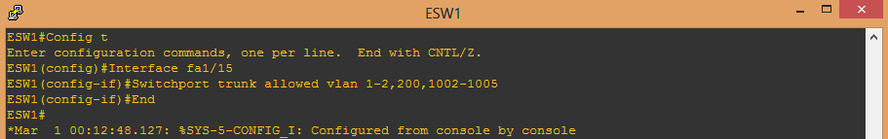

After executing these commands on ESW1, Initially the spanning tree consisted of interface Fast Ethernet 1/15. After executing the above command we have assigned vlan 100 to fast Ethernet 1/15 but we have not allowed 100 in the above command. Hence, FastEthernet1/15 does not appear in the output.

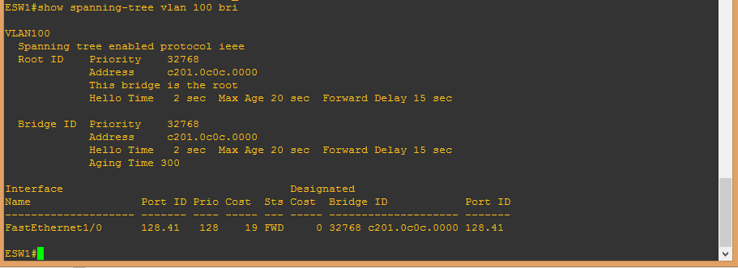

**LACP:**

Link Aggregation Control Protocol (LACP) is a protocol for the collective handling of multiple physical ports that can be seen as a single channel for network traffic purposes.

In order to understand this, we added a new fast Ethernet cable interface fa1/14 between ESW1 and ESW2 switches. By adding this we have aggregated two Ethernet interfaces to form a logical point to point link or bundle.

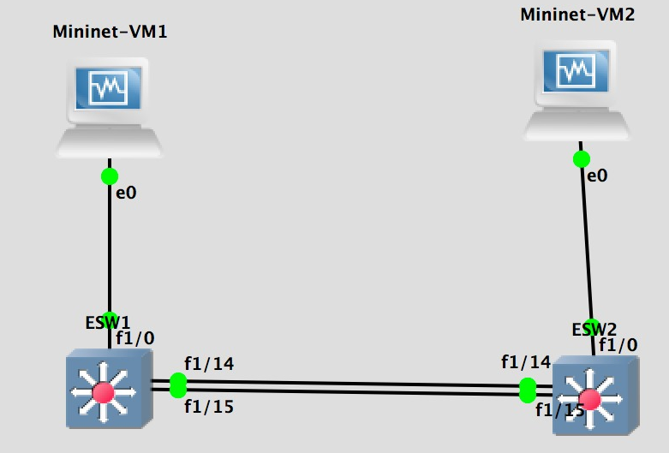

In this new topology, if any of the lines fail then the next line will act as the main line and continue the communication between the hosts.

**Port Channel Configuration:**

Executing the following commands on ESw1 and Esw2:

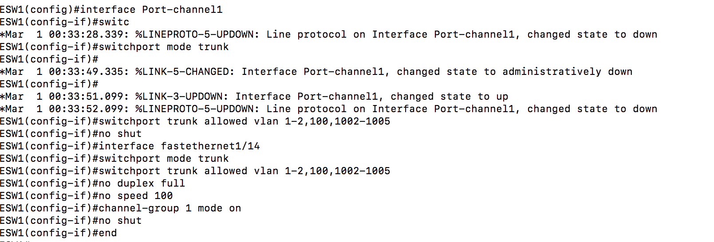

We introduced port channel1 on the switch port in the trunk mode. We also connected port channels of esw1 and 2 using fast Ethernet 1/14.Channel group 1 which comprises of fa1/15 and fa1/14 are in “on Mode”.

We executed “show ip int brief” command in order to make sure that the interfaces fa1/14 and port-channel-1 are both in an up mode.

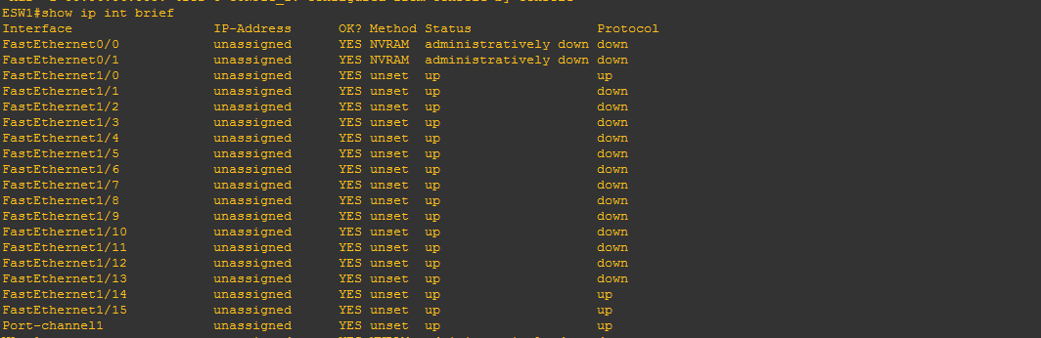

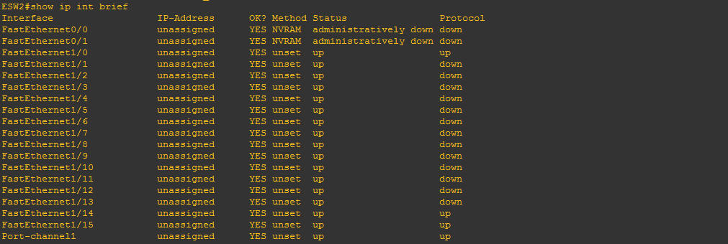

**10. Executed “show spanning-tree vlan 100 br” on switches.**

* ESW1

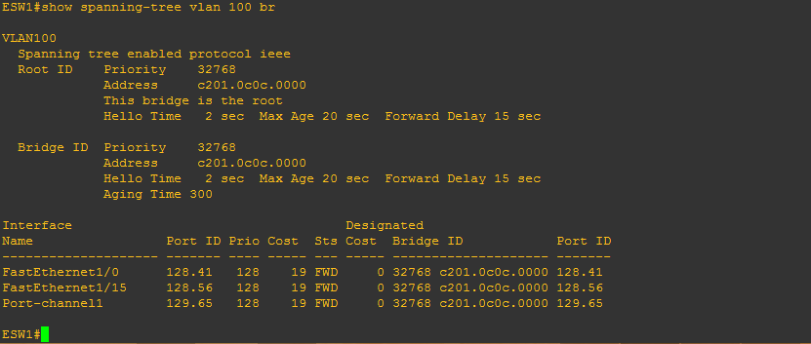

* ESW2

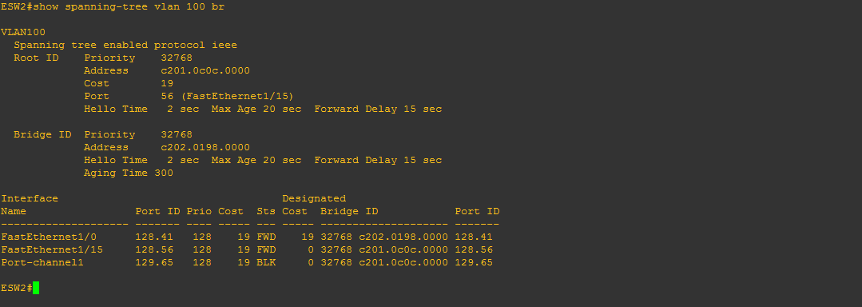

Changes observed: Int fa1/14 was added between ESW 1 and ESW 2 and was bundled into port channel1 with channel group 1 and was made up. Therefore, after executing this command we can see 3 interfaces.

**11. Executed below commands on switches ESW1 and ESW2**

Int fa1/15

Shut

**12.Mininet pings observation.**

After executing “Int Fa1/15” and “Shut” commands mininet pings show destination hosts unreachable and Fa1/14 was up and acted as the main line.

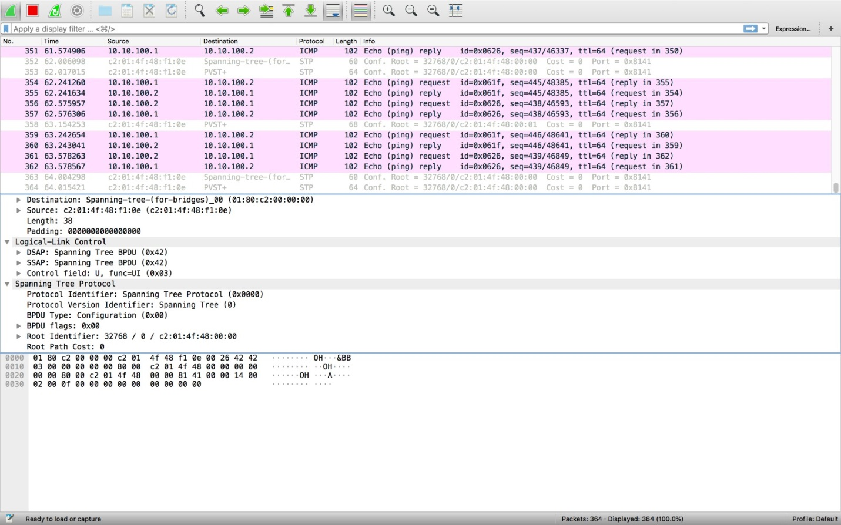

**13.Executing following commands on switches ESW1 and ESW2.**

Int fa1/15

Switchport trunk allowed vlan 1-2,100,1002-1005

Channel-group 1 mode on

No shut

And then we bring Fa1/15 to on mode and communication was started. 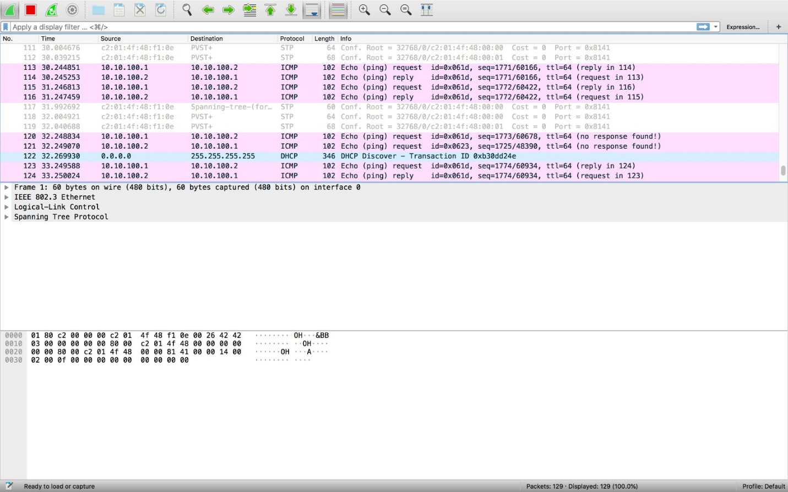

**14. Shutting down a port channel number on switches ESW1 and ESW2.**

Observation from spanning tree indicates that all packets are transmitted through fa1/15 interface link only. And linux servers continued pinging because the link fa1/15 is still up.

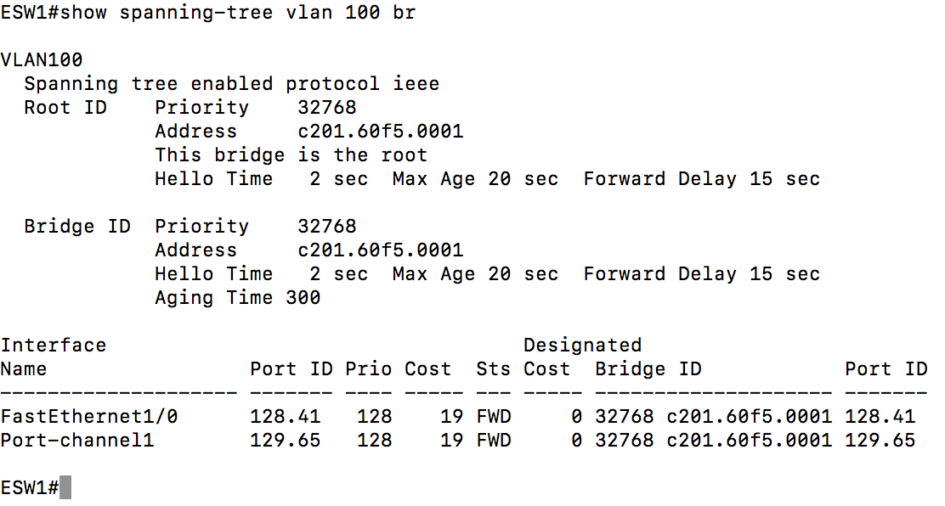

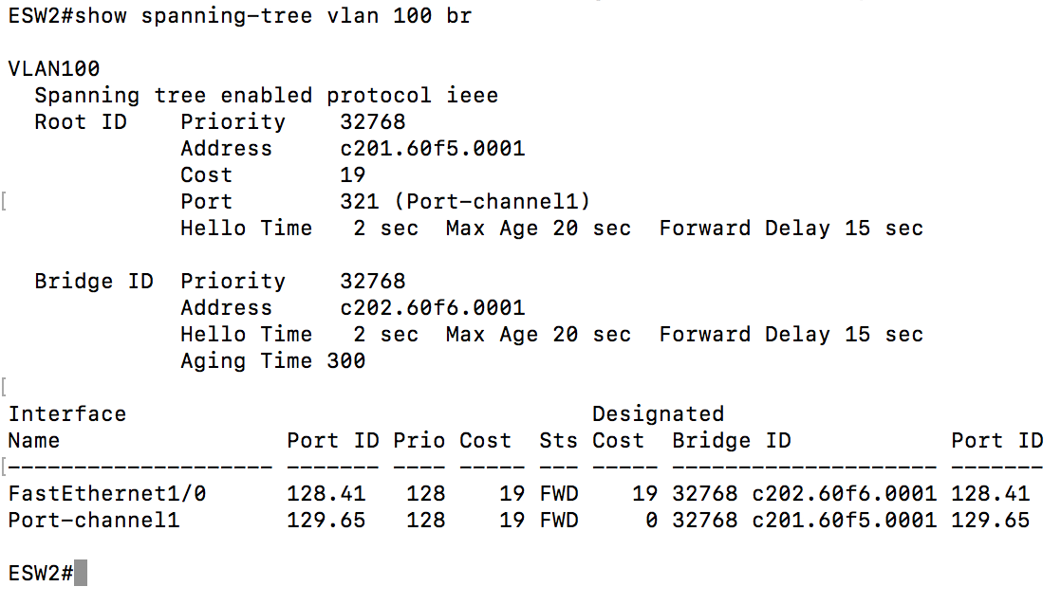

**15. Protocols used in this lab:**

* Address Resolution Protocol [ARP]
* Spanning Tree Protocol [STP]
* Link Aggregation Control Protocol [LACP]
* VLAN Trucking Protocol [VTP]

**16. Ethernet standards employed in this lab:**

802.1 – Bridging

802.2 – Logical Link

802.3 – Ethernet

**Conclusion:**

From this group lab, we configured GNS topology to test various protocols like ARP and LACP which also included learning configuring vlans and Pruning them. The step by step analysis we made during the above work provides good understanding of ARP protocol that is used to map physical address of a host also known as mac-address which is defined at the layer 2 i.e. data-link layer to logical IP address which will be defined at the layer 3(Network layer).Using LACP, we understood that, if one of the line fails then the next line will act as the main line and continue the communication between the hosts.

**References:**

* TCP Illustrated Volume 1, Second edition, The Protocols by Kevin R. Fall and W. Richard Steven.
* https://www.cisco.com/c/en/us/support/docs/ip/dynamic-address-allocation-resolution/13718-5.html
* <https://docs.gns3.com/>
* <https://www.petri.com/csc_arp_cache>
* <https://en.wikipedia.org/wiki/Address_Resolution_Protocol>